OBJECT ORIENTED PROGRAMMING USING JAVA

NAME : P.R.DHANVIN

DEPT & SEC : CSE & B

ROLL NO: 230701071

WEEK : 3

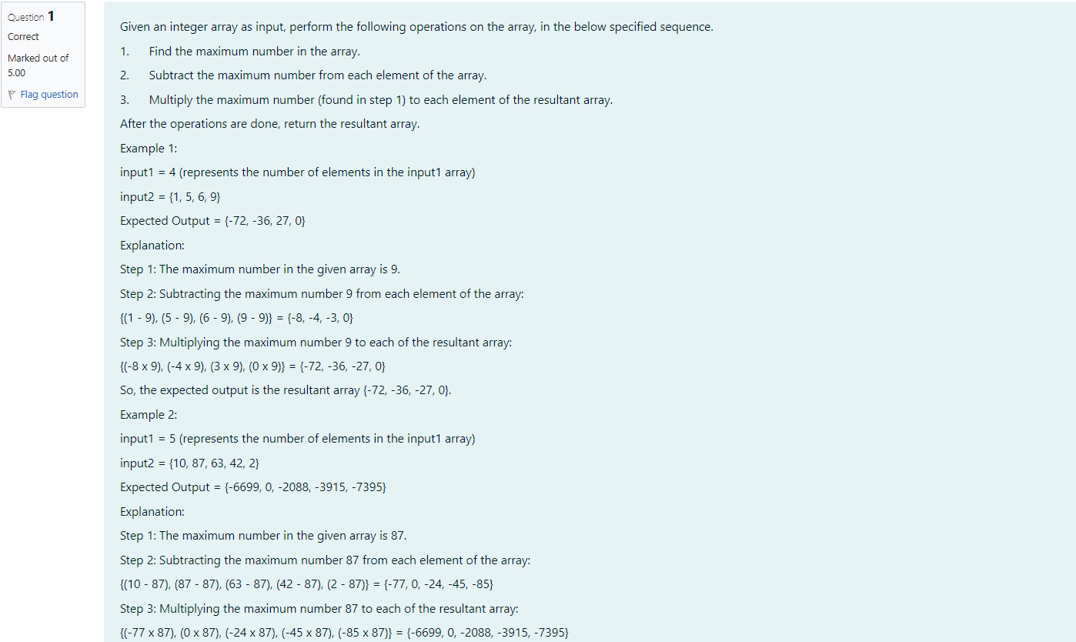

import java.util.Scanner;

public class Array{

public static void main (String[] args) {

Scanner scan-new Scanner(System.in);

int n-scan.nextInt();

int[] numbers= new int[n];

for (int i=0;i<n;i++) numbers[i]=scan.nextInt();

int max-numbers[0];

for(int i=1;i<n;i++){

if(numbers[i]>max) max numbers[i];

}

for(int i=0;i<n;i++) numbers[i]=numbers[i]-max; for (int i=0;i<n;i++) numbers [i]=numbers [i]\*max;

for(int num: numbers) System.out.print(num+" ");

}

}

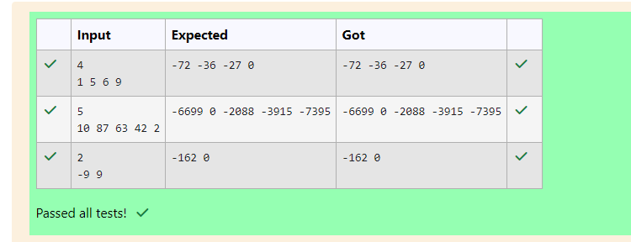

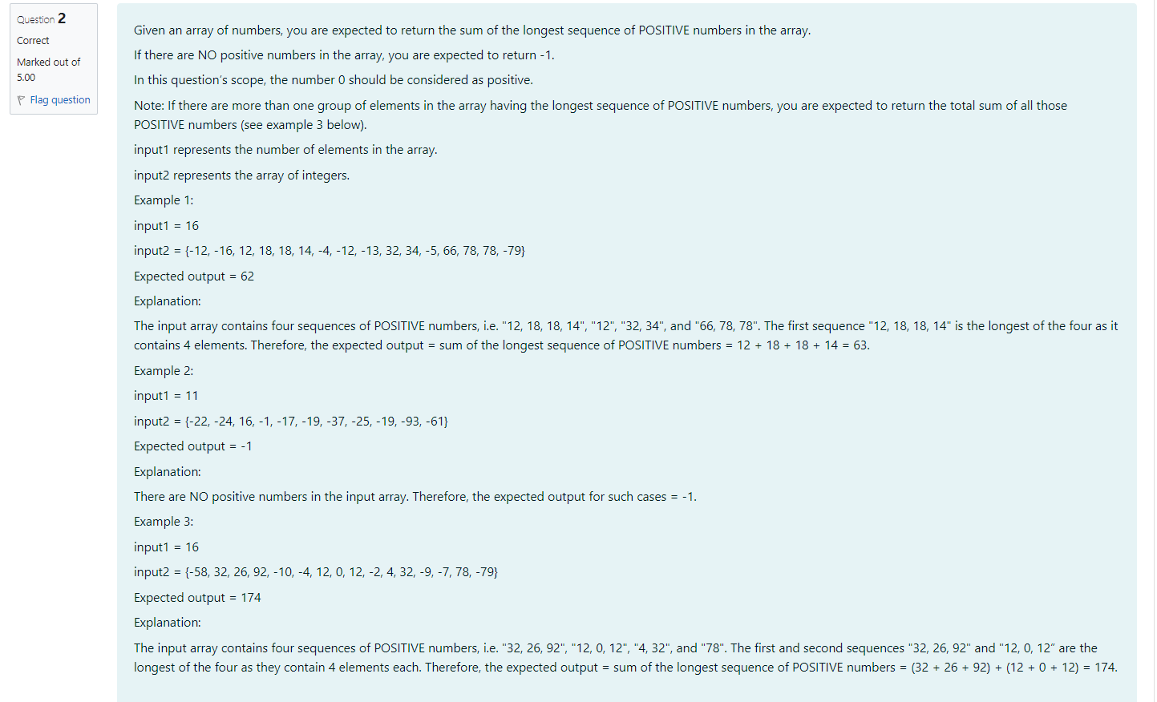

import java.util.Scanner;

public class Long{

public static void main(String[] args){

Scanner scan=new Scanner(System.in);

int n= scan.nextInt();

int[] numbers=new int[n];

for(int i=0;i<n;i++) numbers[i]=scan.nextInt();

int length=0;

int current1=0;

int currents=0;

int sum=0;

for(int i: numbers) {

if(i>=0){

current1++;

currents+=1;

}

else{

if (current1>length) {

length=current1;

sum=currents;

}

else if (current1== length) sum+=currents;

current1=0;

currents=0;

}

}

if (current1>length) sum=currents;

else if (current1== length) sum+=currents;

if(length==0) System.out.print(-1);

else System.out.print(sum);

}

}

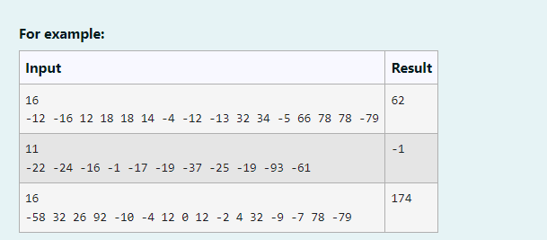

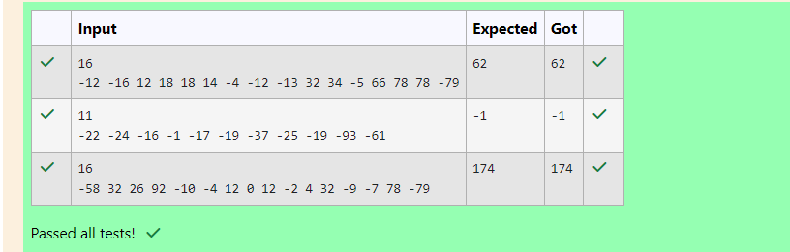

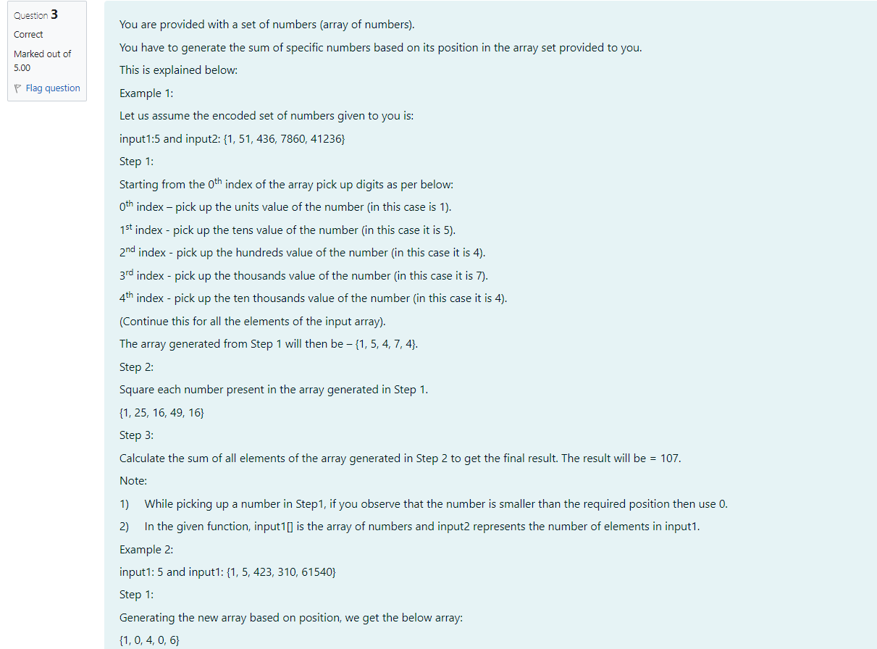

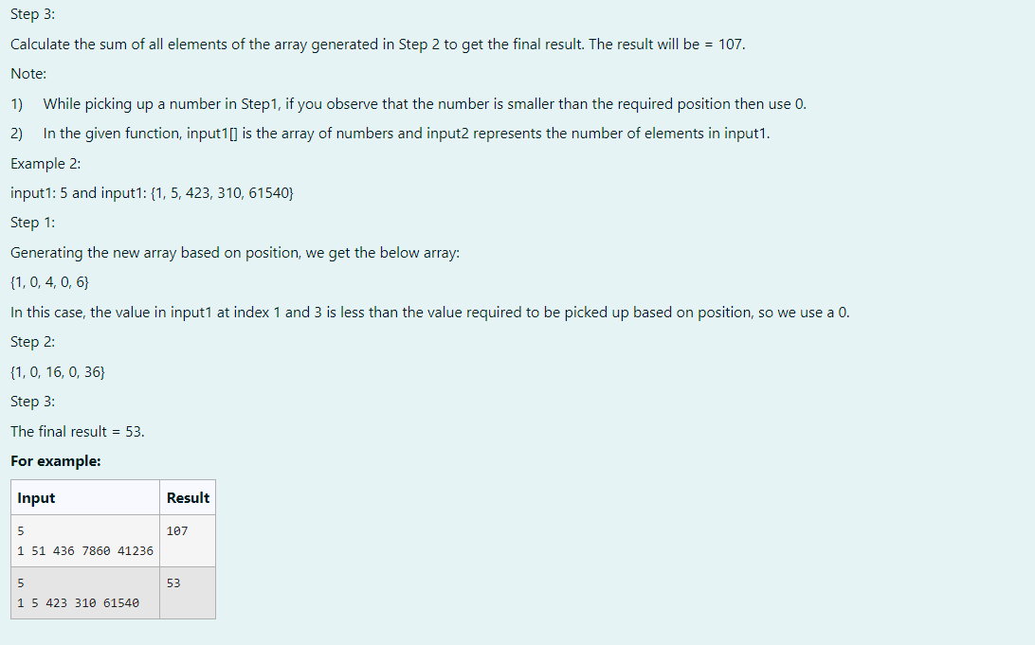

import java.util.Scanner;

public class Sum{

public static void main(String[] args) {

Scanner scan=new Scanner(System.in);

int n=scan.nextInt();

int[] num=new int[n];

for(int i=0;i<n;i++) num[i]=scan.nextInt();

int [] digit=new int[n];

for(int i=0;i<n;i++){

String str=String.valueOf(num[i]);

digit[i]=(i<str.length())? Character.getNumericValue (str.charAt(str.length()-1-1)):0;

}

int sum=0;

for(int i: digit) sum+=i\*i;

System.out.print(sum);

}

}

